Deforestation:

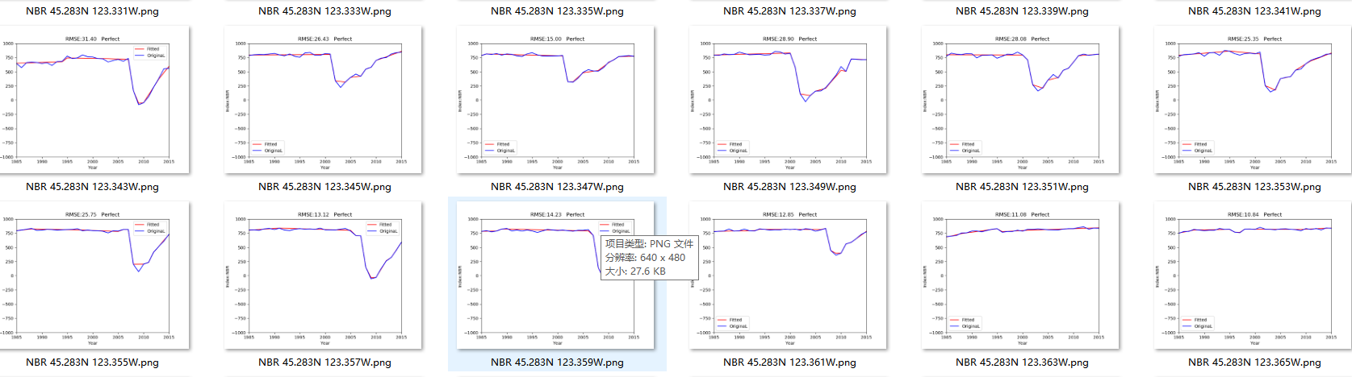

|  |  |
| --- | --- |
| 2007 | 2007 |
| 2010 | 2010 |

Area:

[-123.348,45.289]

[-123.348,45.283]

[-123.343,45.283]

[-123.343,45.289]

2007/

Leaf on/

45123C3313.las

2010/

Leaf on/

PC_028.las

PC_029.las

Afforestation:

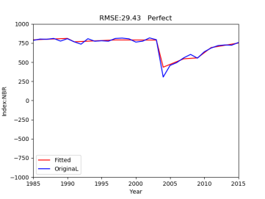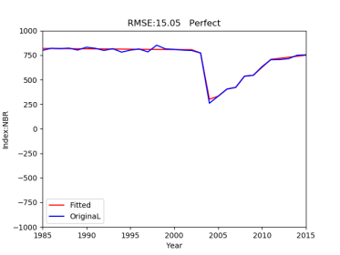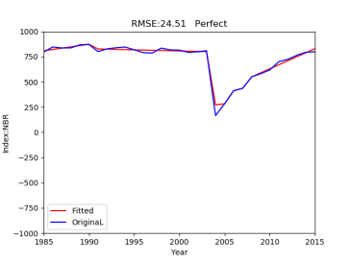

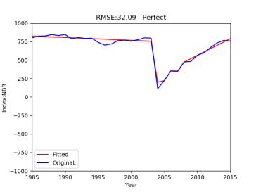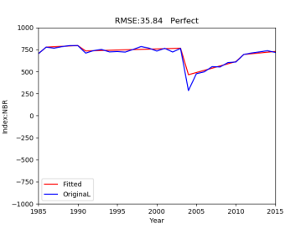

|  |  |
| --- | --- |
| 2007 | 2007 |
| 2010 | 2010 |
| 2015 | 2015 |

Area:

[-123.393,45.308]

[-123.382,45.308]

[-123.382,45.303]

[-123.393,45.303]

2007/

Leaf on/

45123C4404.las

45123C4405.las

2010/

Leaf on/

PC_088.las

PC_089.las

PC_090.las

PC_074.las

PC_075.las

PC_076.las

2015/

Leaf on/

45123C4404.las

45123C4405.las

Insect:

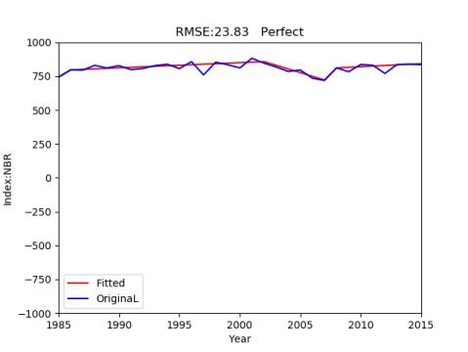

|  |  |
| --- | --- |
| 2003 | 2003 |
| 2006 | 2006 |

Area:

[-123.375,45.281]

[-123.367,45.281]

[-123.367,45.276]

[-123.375,45.276]

2007/

Leaf on/

45123C4415.las

2010/

Leaf on/

PC_002.las

PC_013.las

2015/

Leaf on/

45123C4415.las